Russian Journal of Bioorganic Chemistry, 2026

Evaluation of Cytotoxic Activity of Loaded Catechin into Iron Oxide Nanoparticles Coated with Sodium Alginate and Hydroxyapatite against Human HT-29 Colon Adenocarcinoma and Breast Cancer MCF-7 Cells
M. Nobahariª, K. Shahanipour^{a,}*, S. Fatahianª, and R. Monajemi^{b}
ª Department of Biochemistry, Falavarjan Branch, Islamic Azad University, Isfahan, 3456788 Iran
^{b} Department of Biology, Falavarjan Branch, Islamic Azad University, Isfahan, 3456788 Iran
*e-mail: shahanipur_k@yahoo.com
Received January 30, 2025; revised February 10, 2025; accepted February 11, 2025
Abstract—Objective: With the molecular formula C8H6S, benzothiophene is an appealing synthon showing a wide range of biological activities such as antifungal, antibacterial, antitumor and anticancer properties. Due to increasing concern about the resistance gained by the microorganisms against existing antimicrobial agents, our group is interested in revealing the cellular target site of these compounds. Methods: As a part of our efforts on determination of effect of antibacterial agents, in this study, we focused on the benzothiophene Schiff bases. Antibacterial activity of bis(benzo[b]thiophene-2-yl)alkylmethanimine derivatives was studied via minimum inhibitory concentration measurements. Results and Discussion: One of the compounds, compound I (N,N’-(propane-1,3-diyl)bis(1-(benzo[b]thiophene-2-yl))methanimine), proved to be highly active against both Gram-positives; Staphylococcus aureus, Bacillus subtilis, Enterococcus faecalis, Bacillus cereus; and Gram-negatives Escherichia coli, Pseudomonas aeruginosa, Salmonella enteritidis, Shigella flexneri. In order to reveal the effect of this compound on bacterial cytoplasmic membrane, we measured the extracellular conductivity increase upon treatment. Compound I, showing high antibacterial activity caused a sudden increase of extracellular conductivity due to ion leakage from bacterial cells. In contrast, inactive benzothiophene derivatives did not cause any conductivity increase. Conclusions: We propose that benzothiophene Schiff base I disrupts bacteria cytoplasmic membrane integrity, and this action contributes to its antibacterial activity.
Keywords: catechin hydrate, hydroxyapatite, HT-29 cell, iron oxide nanoparticles, MCF-7 cell

INTRODUCTION
Colon cancer is the third leading cause of cancer-related mortality in the United States. Globally, it is the fourth leading cause of death among all cancers [1, 2]. Breast cancer is considered the second cause of mortality in women worldwide [3]. Surgery, chemotherapy, radiotherapy, immunotherapy, and hormone therapy are the main tools of cancer treatment; however, they show considerable adverse effects [4]. Conventional chemotherapy bears side effects due to non-speciﬁc effects on normal tissues and the development of multidrug resistance in tumors [5]. To overcome these problems, various plant-derived anticancer agents, are available for clinical use owing to their diverse biological functions, as well as with minimal side effects to normal tissues [6]. Catechin hydrate (CH) (Fig. 1) is a natural flavonoid compound extracted from plants, which is found in natural food and drinks, such as green tea and red wine. CH shows antioxidative and anti-inflammatory properties [7, 8]. Chatechinhydrate has indicated promising antiproliferative potentials against several cancer cells [9]. However, its limited systemic bioavailability restricts its application as an oral therapeutic agent [10]. To address this limitation, nanoparticulated-drug delivery systems have been widely used in order to deliver anticancer agents to tumors.
Drug delivery systems are generally referred to as carriers capable of binding to or holding and carrying drugs in the body. Nanostructures can penetrate into cancerous tissues, specifically through either passive such as enhanced permeability and the retention effect, or active for example by binding to ligands such as small molecules, peptides, or antibodies transport systems. The development of nanoparticle-based materials for the release of therapeutic agents has provided a promising approach to improve the solubility, stability and bioavailability of therapeutic agents. In fact, this targeted release system leads to increased treatment efficiency, reduced drug dose and reduced toxicity of therapeutic agents in healthy tissues. Among the materials that are widely used in drug delivery systems are magnetic iron oxide nanoparticles, which have received much attention due to their special properties such as their small size, low toxicity, ability to carry hydrophobic drugs, biodegradability, biocompatibility, high specific surface area [11, 12].
However, agglomeration has limited the application of these nanoparticles [13], which has been resolved using surface functionalizing compounds, including sodium alginate (NaAlg) and hydroxy apatite (HAp). These compounds, as natural inorganic materials, present excellent and favorable biocompatibility biodegradability, immunogenic, and osteoconductivity properties [14]. These are non-toxic polymers widely used as biomaterials in this regard. Therefore, the purpose of the current research was to develop a drug delivery system based on coated IONPs to enhance the therapeutic efficacy of catechinhydrate. We evaluated the physicochemical properties of the nanoparticles (NPs) and determined the drug release profile. The anticancer effects of the nano-formulations were assessed against the HT-29 and MCF-7 cell lines, representing colon and breast cancers, respectively.
There are various methods for the production of nanoparticles, including physical and chemical methods such as milling, pulsed laser ablation, co-precipitation, sol-gel synthesis, ion implantation. In the physical method, the production of nanoparticles is through processes such as milling or pulverization. Chemical synthesis involves the growth of nanoparticles in a liquid medium containing a variety of reactants, such as condensation from a vapor. This method evaporates a solid metal and then rapidly condenses to form nanometer clusters that settle into a powder. Co-precipitation method is one of the oldest methods of making nanoparticles that was first used to synthesize magnetite nanoparticles. The advantage of this method is that it is cheap and it does not take time and also a large amount of nanoparticles can be made in a small volume of reaction [15].
RESULTS AND DISCUSSION
Assessment of DL efficiency. Drug encapsulation efficiency is an important factor to investigate the performance of dryg carriers. Catechinhydrate-encapsulated IONPs were prepared 20.31 ± 0.64 drug loaded in the nanoparticles and showed 81.25 ± 2.55% encapsulation efficiency.
SEM and TEM analyses. The results of SEM showed that the prepared NPs were spherical in shape and relatively monodisperse in size (Fig. 2a). Also, TEM results showed spherical and smooth surfaces in NPs with an average particle size of 9–13 nm. (Fig. 2b). Particle size is considered an important factor in determining the efficacy of drug delivery systems because it affects the pharmaceutical properties of the drug, including its release profile and cellular uptake.
Fourier transform infrared spectroscopy (FT-IR) analysis. The FT-IR spectra of IONPs, NaAlg/HAp, IONPs@NaAlg/HAp, CH, and IONPs@NaAlg/HAp-CH after absorption have been shown in Fig. 3. The FT-IR spectrum of the IONPs showed significant absorption bands around 630 and 3423 cm^{–1} , which are related to the tensile vibration of the Fe–O and O–H groups of IONPs. In the FT-IR spectrum of Hap and NaAlg nanoparticles, the absorption peaks around 570, 1046, 1384, 1637, and 3426 cm^{–1} were related to the stretching modes of the O–H group [20]. The FT-IR spectrum of IONPs@HAp/NaAlg particles showed the apparent interactions of NaAlg with both HAp and IONPs, characterized by COOH symmetrical and asymmetrical stretching vibrations at 1625 and 1384 cm^{–1}, respectively [21, 22]. As shown, the spectrum of IONPs had three absorption peaks around 583, 1627, and 3423 cm^{–1}, with the highest absorption intensity at 583 cm^{–1}. The diagrams of the hydroxyapatite and sodium alginate coatings also showed absorption peaks around 823, 562, 1046, 1384, 1637, 3426, 2005, and 3426 cm^{–1}, with the latest two showing the highest absorption. The spectrum of the IONPs coated with hydroxyapatite and sodium alginate demonstrated absorption peaks at 563, 1030, 1625, 2005, 2923, and 3424 cm^{–1}, whth more intensity at the numbers of 563, 1030, and 3424 cm^{–1}. Strong absorption around 563 cm^{–1} was due to the crystal structure of iron oxide. On the other hand, a significant absorption at 3424 cm^{–1} resulted from the overlap of 3423 cm^{–1} (related to pure IONPs) and 3426 cm^{–1} (related to hydroxyapatite and sodium alginate) absorption peaks. Other absorption peaks observed in the spectrum of the IONPs coated with hydroxyapatite and sodium alginate, such as 1030 and 2005 cm^{–1} are very similar to those of hydroxyapatite and sodium alginate, all of which indicated the success of the coating process. The correct coating of hydroxyapatite and sodium alginate depends on the iron nano oxide sample. Similarly, the main absorption peaks around 600, 1100, 1400, 1600, and 3400 cm^{–1} were in fact due to overlapping peaks. These main absorption peaks corresponded to the iron oxide sample coated with hydroxyapatite and sodium alginate, which were both loaded with catechin. The absorption peaks indicated that the NPs were successfully coated and then loaded with catechin.
A strong interaction between catechin, as a hydrophobic drug, and hydroxyapatite-coated IONPs [21]. The FT-IR analysis revealed no chemical interaction between IONPs and catechinhydrate, ensuring that catechinhydraten could be entrapped into the NPs without alteration in itsnatural structure.
XRD analysis. The XRD patterns of the IONPs have been depicted in Figs. 4a–4b. The XRD pattern at 20 of 30.1, 35.6, 43.3, 53.5, 57.63, and 74 demonstrated that the synthesized magnetic NPs has the inverted spinel structure crystal structure and also is in a single phase. These findings are according to the standard JCPDS (Joint Committee on Powder Diffraction Standards) card no. 01-075-0449 [23].
In vitro drug release. Figure 5 represents catechinhydrate release pattern from coated IONPs at two different pH (5.5 and 7.5).The results demonstrated an abrupt release during the first 20 to 24 h at both pH, which then continued steadily for 240 h. However, the amount of release catechinhydrate was higher at pH = 5.5, followed by a more gradual release at longer periods of time until reaching a release percentage of 93.96 ± 0.75% while this rate was about 49.06 ± 0.71% at pH = 7.5. This may be explained by the slow degradation of HAp-coated materials in acidic media. Since cancerous cells have a pH lower than that of normal cells, this faster release at the lower pH can enhance the effectiveness of targeting tumors and drug release into tumor microenvironment [24].
In vitro cytotoxicity. The in vitro cytotoxic effects of HAp/NaAlg-coated IONPs, free catechinhydrate and catechinhydrate loded on IONPs were assessed against the HT-29 and MCF-7 cancer cell lines by the MTT test after 24, 48, and 72 h of treatment. No obvious cytotoxicity was observed for the IONPs coated with HAp/NaAlg at the studied concentrations. Both free catechinhydrate and catechinhydrate loded IONPs exhibited concentration and time-dependent cytotoxicity. The antiproliferative effect of catechinhydrate-loded IONPs was significantly higher than that of free catechinhydrate at the same concentration and incubation time (Figs. 6, 7).
The results showed that at 24, 48, and 72 h after treating the cell lines with catechinhydrate- loaded IONPs, the mean percentage of cell survival at all concentrations was significantly different compared with the control group (p <0.001).
Higher IC50 values (Tables 1, 2), as the drug concentration required to inhibit the growth of 50% of tumor cells (HT-29 and MCF-7) during a certain period, were obtained for free catechinhydrate and catechinhydrate-loded coated IONPs, confirming the higher cytotoxic effects of catechinhydrate-loaded IONPs, probably due to the higher uptake of the drug-loaded NPs [25].
Flow cytometry. The results of annexin/PI staining to determine alive/apoptotic/late apoptotic/dead HT-29 and MCF-7 cells have been presented in Figs. 8–9, respectively. The results showed that in comparison with free catechinhydrate, the cells treated with catechinhydrat-loaded HAp/NaAlg-coated IONPs showed a higher percentage of cells in either the late-apoptosis, necrosis, or death phases.
Regarding the HT-29 cell line, the percentage of alive cells in the control group was 78.3%, which was higher than that of other groups. The percentage of apoptotic cells increased from 93%, in the cells incubated with catechinhydrate to 2.48%, in those incubated with catechinhydrate-loaded HAp/NaAlg-coated IONPs. Moreover, the percentage of cells in late apoptosis rose from 12.6%, in the cells incubated with catechinhydrate to 20.5%, in the cells incubated with catechinhydrate-loaded HAp/NaAlg-coated IONPs.
For MCF-7 cells, the percentage of alive cells in the control group was 87.4%, which was higher compared to other groups. The percentage of apoptotic cells increased from 11.7%, in the cells incubated with catechinhydrate to 30.9% in those incubated with catechinhydrate-loaded HAp/NaAlg-coated IONPs. Moreover, the percentage of cells in late apoptosis rose from 7.44%, in the cells incubated with catechinhydrate to 66.3% in the cells incubated with catechinhydrate-loaded IONPs -HAp-NaAlg.
EXPERIMENTAL
Synthesis of HAP and NaAlg- coated Iron oxide nanoparticles (IONPs). Synthesis of iron oxid nanoparticles by chemical co-precipitation was performed in a 500 ml three-port glass reactor at 80°C with continuous stirring by magnetic stirring. Briefly 3.2 g iron (III) chloride (FeCl₃, 6H₂O) and 2.78 g iron (II) sulfate (FeSO₄, 7H₂O) were dissolved in distilled water, and 2.4 g NaOH solution was then added to the solution. A 20-min degassing was performed under nitrogen atmosphere.The resulting precipitate was collected magnetically, washed with deionized water several times, and then dried. The obtained product was used for HAp calcium (II) nitrate (Ca(NO₃)₂ and (NH₄)₂HPO₄), and NaAlg (alginic acid sodium salt )low viscosity)) coating. Then 0.5 g of IONPs was dissolved in distilled water and mixed with NaAlg powder and 0.25 M calcium (II) nitrate Ca(NO₃)₂ and (NH₄)₂HPO₄. The pH of the system was maintained in the range of 8–9. Finally, the resultant was washed 2–3 times with deionized water [13].

Here is an example of the correct formatting of the data of the experimental part. Please format the data according to the sample (pay attention to the formatting of the data, the order of the parts, etc.)

(E)-1-(4-(Piperazin-1-yl)phenyl)-3-(2-(trifluoro-methyl)phenyl)prop-2-en-1-one (IV). Yellow solid. Yield: 54%. mp: 290–291°C. FT-IR (ν_{max}, cm⁻¹): 3369 (N–H), 2934 (Ar–CH), 1657 (C=O), 1586–1588, 1519, 1483, 1454 (C=C), 1189 (C–F). ¹H NMR (600 MHz, DMSO-d₆), ppm: 3.18 (s, 4H, H₁), 3.64 (s, 4H, H₂), 7.08 (d, J = 7.20 Hz, 2H, H₄), 7.63 (t, J₁ = 8.40 Hz, J₂ = 7.80 Hz, 1H, H₁₃), 7.76 (t, J₁ = 8.40 Hz, J₂ = 7.80 Hz, 1H, H₁₄), 7.80 (d, J = 8.40 Hz, 1H, H₁₅), 7.90 (d, J = 15.00 Hz, 1H, H₈), 8.02 (d, J = 15.00 Hz, 1H, H₉), 8.11 (d, J = 7.20 Hz, 2H, H₅), 8.32 (d, J = 7.80 Hz, 1H, H₁₂). ¹³C NMR (150 MHz, DMSO-d₆), ppm: 42.59, 44.08, 114.27, 123.76, 126.72, 127.92, 128.66, 129.20, 130.66, 131.35, 131.75, 133.38, 133.57, 136.83, 153.71, 186.62 (C=O). ESI-MS (m/z): 395 [M + H]⁺. C₁₉H₁₈N₆O₂S. Calculated, %: C, 57.85; H, 4.60; N, 21.31. Found, %: C, 57.88; H, 4.62; N, 21.34.
In vitro loading of catechin hydrate into IONPs. For the loading of catechin hydrate into IONP, coated with HAp-NaAlg, 5 mg of catechin hydrate was dissolved in water – ethanol mixtures and was added dropwise to 20 mg of an IONP/HAp-NaAlg aqueous suspension, followed by stirring at 400 rpm for 24 h to allow catechin hydrate to permeate into the NPs. At the end, the resulting mixture was washed to separate free CH from the coated IONPs-containing CH.
Scanning electron microscopy. To evaluate surface morphology, scanning electron microscopy (SEM) (Philips XL30, the Netherlands) was used.
Transmission electron microscopy. To evaluate the size of NPs, transmission electron microscopy (TEM) (JEOL, Tokyo, Japan) was used. A drop of IONPs suspension was placed on a carbon coated copper TEM grid and allowed to air-dry. The dried samples were then examined at 120 kV under the microscope.
Fourier transform infrared spectroscopy. For Fourier transform infrared (FT-IR) spectroscopy analysis IONPs, NaAlg/HAp, IONPs@NaAlg/HAP, CH, and IONPs@NaAlg/HAP-CH were scanned over a wavenumber range of 4000–400 cm^{–1} using an FT-IR spectrophotometer (Perkin Elmer 65, USA) to understand the possible chemical interactions occurring between the drug and NPs.
X-ray diffraction study. To determine the crystalline structure of the IONPs, X-ray diffraction (XRD) patterns were measured. The experiment was performed by a D/Max – B Rikagu diffractometer (AW-XDM300, the UK). All the experiments were performed at room temperature.
In vitro drug release. To measure the in vitro release of catechinhydrate from IONPs, 3 mg of the sample was transferred into 6 mL of PBS (pH = 7.5 and 5.5) and stirred at 100 rpm and 37ºC. At certain time points, 1 mL of the solution was replaced with the same amount of fresh PBS. The mixture was then centrifuged (8000 rpm, 25 min). The absorbance of each sample was measured by an UV-visible spectrophotometer at 230 nm, and the concentration of catechinhydrate released from IONPs was determined using a standard calibration curve. The release experiments were performed in triplicate. Data were plotted as the percentage of cumulative drug release versus time [17].
In vitro cytotoxicity assessment. The cytotoxic effects of coated IONPs free catechinhydrate and CH loaded IONPs were assessed against the HT-29 and MCF-7 cancer cell lines by the MTT assay. Briefly, cells were plated at a density of 1 × 104 cells per well in 96-well plates and cultivated at 37°C in humidified air containing 5% CO₂ (Heal Force HF-90, Japan) for 24 h. Then the cells were treated with various concentrations (50–500 µg/mL) of coated IONPs, free catechinhydrate and CH loaded IONPs and incubated for 24, 48 and 72 h at 37˚C. After the specified incubation time, the culture medium was discarded, and 20 µL of MTT (5 mg/mL) solution was added to each well, and incubation continued for 4 h at 37˚C. The supernatant was withdrawn and 150 µL DMSO was added to each well to dissolve formazan crystals. The UV absorbance of solubilized formazan crystals was determined using spectrophotometry at 570 nm by a microplate reader. The experiment was performed in triplicate [18].
Flow cytometry. For apoptosis assessment, HT-29 and MCF-7 cells were treated for 72 h. After washing with PBS and trypsin, the cells were separated from the culture medium by centrifugation. The cells were washed with the buffer solution and centrifuged at 15000 rpm for 15 min. After that, 5 μL of annexin-V (BD Pharmingen) and Propidium iodide were added to the cells, and the cells were incubated for 15 min at room temperature in dark and then evaluated by flow cytometry (BD FACS Calibur) [19]. All experiments were undertaken in triplicated.
CONCLUSIONS
Nanotechnology in the field of pharmaceutics seeks new models for targeted drug delivery to tumor cells, which is more effective in suppressing cancer progression and while reducing drug side effects. Therefore, it is essentialto find antitumor compounds that have fewer side effects, and herbal medicines among of these compounds.
In the present study, IONPs were synthesized, coated with HAp/NaAlg, and then loaded with catechinhydrate. Catechinhydrate release was measured for 10 days, which showed a faster release in acidic pH (i.e., mimicking tumor microenvironment). Antiproliferative tests showed that IONPs@HAp-NaAlg@CH had high cytotoxicity against colon and breast cancer cells, with IC₅₀ values lower than that of free catechinhydrate. Flow cytometry results, also confirmed the results of the MTT assay, indicating that catechinhydrate-coated IONPs increased the rate of apoptosis in the cancer cell lines.
Catechinhydrate-coated IONPs showed good cytotoxic effects against both HT-29 and MCF-7 cells, and this effect was more prominent against MCF-7. Therefore, this formulation can be regarded as an antitumor compound for treating various cancers, including colon and breast cancers. Before conducting clinical trials in humans, experimental studies should be performed on large rodents.
FUNDING
This work was supported by regular institutional funding, and no additional grants were obtained.
ETHICS APPROVAL AND CONSENT TO PARTICIPATES
This article does not contain any studies conducted by any authors of this work. This article does not contain any studies involving patients or animals as test objects.
Informed consent was not required for this article.
CONFLICT OF INTEREST
No conflict of interest was declared by the authors.
AUTHOR CONTRIBUTION
For authors: add AC. Example: Authors ASK and DAE—selected the literature data on the review topic. Authors ASK, DAE, TSO, and EAK—contributed to manuscript preparation. All authors participated in the discussions.
DATA AVAILABILITY
The data that support the findings of this study are available from the corresponding author upon reasonable request.
REFERENCES
Particular attention should be paid to references in the list of references.

The Journal prohibits et al. All authors must be listed.
You cannot combine multiple links into one. Each link must have its own serial number.
You cannot give the full name of the Journals - you need to give the official abbreviation.
Page spacing is indicated by a dash – rather than a hyphen.
Last name comes first, then initials
Pay attention to commas (where they need to be placed)
There should be no spaces between initials
Notice where you need to add ", and"

- Radhakrishnan, E.K., Bava, S.V., Narayanan, S.S., Nath, L.R., Thulasidasan, A.K.T., Soniya, E.V., and Anto, R.J., PLOS ONE, 2014, vol. 9, p. 104401. https://doi.org/10.1371/journal.pone.0104401
- Wang, Y., Yu, J., Cui, R., Lin, J., and Ding, X., J. Lab. Automat., 2016, vol. 21, pp. 723–731. https://doi.org/10.1177/2211068216655524
- Anjum, F., Razvi, N., and Masood, M.A., MOJ Drug. Des. Develop. Ther., 2017, vol. 1, pp. 35–38. https://doi.org/10.15406/mojddt.2017.01.00006
- Abdel-Moneim, A., and Magdy, A., Eur. J. Biomed. Pharm. Sci., 2016, vol. 3, pp. 45–62.
- Khan, T., Ali, M., Khan, A., Nisar, P., Jan, S.A., and Afridi, S., Biomolecules, 2020, vol. 10, pp. 47–77.
- Poonam, S., and Chandana, M., Int. J. Pharm. Tech. Res., 2015, vol. 8, pp. 131–141.
- Li, J., Lee, I.W., Shin, G.H., Chen, X., and Park, H.J., Eur. J. Pharm. Biopharm., 2015, vol. 94, pp. 322–332.
- Hosseinimehr, S.J., J. Clin. Exc., 2014, vol. 2, pp. 50–63.
- Alshatwi, A.A., J. Exp. Clin. Cancer Res., 2010, vol. 29, p. 167.
- Paul, A.S., Das, J., Samadder, A., and Khuda-Bukhsh, A.R., Toxicol. Lett., 2013, vol. 222, pp. 10–22.
- Heydari Sheikh Hossein, H., Zarrabi, A., and Zarepour, A., J. Babol. Univ. Med. Sci., 2017, vol. 19, pp. 64–70.
- Ramezani Ali Akbari, K., and Abdi Ali, A., Nanomed J., 2017, vol. 4, pp. 37–43.
- Manatunga, D.C., de Silva, R.M., de Silva, K.M.N., de Silva, N., Bhandari, S., and Yap, Y.K., Eur. J. Pharm. Biopharm., 2017, vol. 117, pp. 29–38. http://dx.doi.org/10.1016/j.ejpb.2017.03.014
- Salehi, M., Ai, A., Ehterami, A., Einabadi, M., Taslimi, A.R., and Ai, A., Nanomed J., 2020, vol. 7, pp. 115–123. http:// doi: 10.22038/nmj.2020.07.004
- Patil, N., Bhaskar, R., Vyavhare, V., Dhadge, R., Khaire, V., and Patil, Y., Int. J. Curr. Pharm. Res., 2021, vol. 13, pp. 11–16.
- Manikkam, R., and Pitchai, D., World J. Pharm. Sci., 2014, vol. 2, pp. 1553–1577.
- Akrami, M., Khoobib, M., Khalilvand-Sedaghehb, M., Haririana, I., Bahadord, A., and Faramarzie, M.A., RSC Adv., 2015, vol. 5, pp. 88096–88107. https://doi.org/10.1039/C5RA13838H
- Zeng, L., Yan, J., Luo, L., Ma, M., and Zhu, H., Sci. Rep., 2017, vol. 7, p. 45521. https://doi.org/10.1038/srep45521
- Manatunga, D.C., de Silva, R.M., Nalin de Silva, K.M. Neelika Malavige, G., Wijeratne, D.T., and Williams, G.R., Eur. J. Pharm. Biopharm., 2018, vol. 128, pp.18–26. https://doi.org/10.1016/j.ejpb.2018.04.001
- Jegan, A., Ramasubbu, A., Saravanan, S., and Vasanthkumar, S., Int. J. Nano Dimens., 2011, vol. 2, pp. 105–110.
- Ahn, S., Seo, E., Kim, K., and Lee, S.J., Sci. Rep., 2013, vol. 3, p. 1997. https://doi.org/10.1038/srep01997
- Painter, P.C., Snyder, R.W., Starsinic, M., Coleman, M.M., Kuehn, D.W., and Davis, A., Appl. Spectrosc., 2018, vol. 35, pp. 475–485.
- Cai, H. An, X., Cui, J., Li, J., Wen, S., and Li, K., ACS Appl. Mater. Int., 2013, vol. 13, pp. 1722–1731. http://dx.doi.org/10.1021/am302883m
- Bano, S., Afzal, M., Waraich, M.M., Alamgir, K., and Nazir, S., Int. J. Pharm., 2016, vol. 513, pp. 554–563. http://doi:http://dx.doi.org/10.1016/j.ijpharm.2016.09.051
- Liao, S.H., Liu, C.H., Bastakoti, B.P., Suzuki, N., Chang, Y., and Yamauchi, Y., Int. J. Nanomed., 2015, vol. 10, pp. 3315–3328.

Table 1. The IC₅₀ values of free catechinhydrate and catechinhydrate loaded coated IONPs against the HT-29 cell line after 24, 48, and 72 h of incubation
IC₅₀ (g/mL)ª
HT-29 cell line
Time (h) | Catechinhydrate | Catechinhydrate loaded coated ION NPs
24 | 1.17 ± 134.90 | 1.16 ± 93.63
48 | 1.15 ± 98.63 | 1.14 ± 69.02
72 | 1.14 ± 69.78 | 1.13 ± 49.64
ª Showing mean ± SD (n = 3).

Table 2. The IC₅₀ values of free catechinhydrate and catechinhydrate loaded coated IONPs against the MCF-7 cell line after 24, 48, and 72 h of incubation
IC₅₀ (g/mL)ª
MCF-7 cell line
Time (h) | Catechinhydrate | Catechinhydrate loaded coated ION NPs
24 | 1.18 ± 103.75 | 1.14 ± 68.52
48 | 1.16 ± 74.64 | 1.11 ± 54.57
72 | 1.12 ± 49.38 | 1.21 ± 34.65
ª Showing mean ± SD (n = 3).

All figures and schemes must be provided separately as an archive. Schemes must be typed in the ChemDraw program (+ source files with the *cdx extension must be provided); figures can be provided in any editable format: Photoshop, Adobe Illustrator, CorelDraw, PowerPoint and others (the main thing is that we can make corrections to the inscriptions).

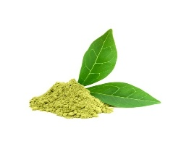
Fig. 1. Molecular structure of catechin hydrate.

(a)
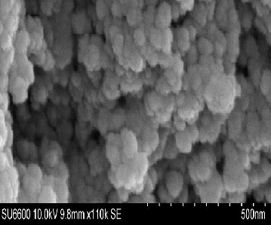
(b)
Fig. 2. (a) SEM images and (b) TEM images of iron oxide nanoparticles.

Fig. 3. Comparison of the FTIR spectra of HAP and NaAlg (green), Fe₃O₄-Iron (III) oxide/HAP-NaAlg (yellow), catechin (red), and catechin/Fe₃O₄-Iron (III) oxide -HAP-NaAlg (blue).

(a)
(b)
Fig. 4. (a) The X-ray diffraction pattern of IONP_{S} and (b) phases of the nanoparticles synthesized.
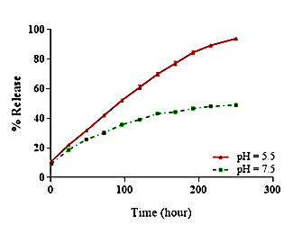
Fig. 5. In vitro cumulative release percentage of catechin hydrate from IONPs/HAP-NaAlg under two buffer conditions (pH = 5.5 and 7.5).

(a)
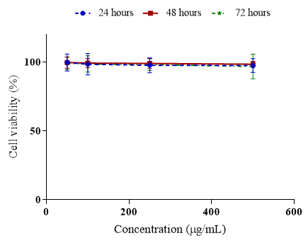
(b)
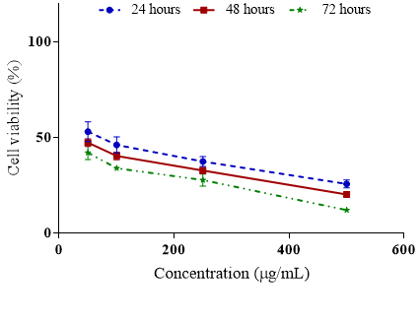
(c)
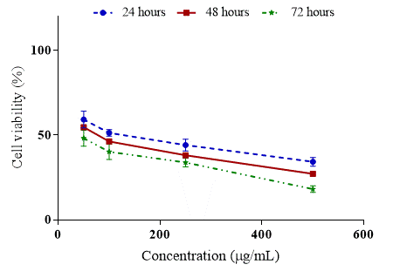
Fig. 6. Viability of the HT-29 cells treated with 50, 100, 250, and 500 μg/mL of (a) coated IONPs, (b) catechinhydrat loaded coated IONPs and (c) catechinhydrate for 24, 48, and 72 h (mean ± SD, p-value <0.001).
(a)
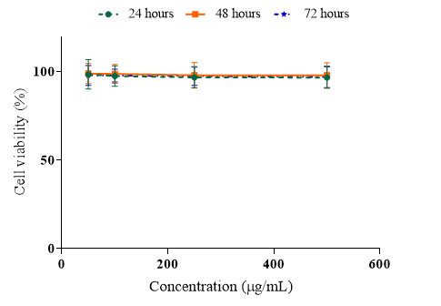
(b)
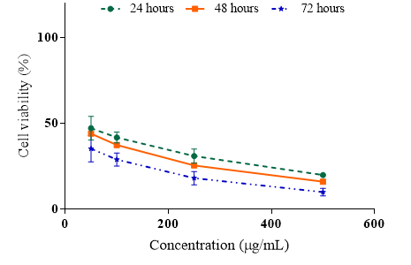
(c)
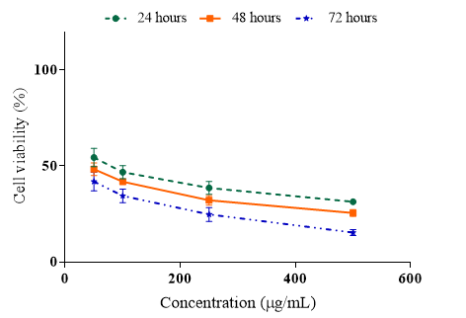
Fig. 7. Viability of the MCF-7 cells treated with 50, 100, 250, and 500 μg/mL of (a) coated IONPs, (b) catechinhydrat loaded on coated IONPs and (c) catechinhydrate for 24, 48, and 72 h (mean ± SD, p-value <0.001).

(a)
(b) (c)
Fig. 8. Flow cytometric analysis of HT-29 cell: (a) control group, (b) catechin hydrate bound nanoparticles, and (c) catechin hydrate.

(a)

(b) (c)
Fig. 9. Flow cytometric analysis of MCF-7 cells: (a) control group, (b) catechin hydrate bound nanoparticles, and (c) catechin hydrate.

